**Natural Language Processing (NLP) with Spacy and NLTK**

Introduction to Natural Language Processing : NLP stands for Natural Language Processing, which is a part of Computer Science, Human language, and Artificial Intelligence. It is the technology that is used by machines to understand, analyse, manipulate, and interpret human's languages. It helps developers to organize knowledge for performing tasks such as translation, automatic summarization, Named Entity Recognition (NER), speech recognition, relationship extraction, and topic segmentation.

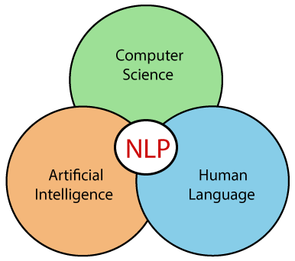

**Key Features**

* Tokenization
* Part-of-Speech Tagging
* Named Entity Recognition
* Sentiment Analysis
* Parsing
* Stemming and Lemmatization

**Basic NLTK Examples**

import nltk

# Tokenization

text = "Natural Language Processing is fascinating!"

tokens = nltk.word_tokenize(text)

# Part-of-Speech Tagging

pos_tags = nltk.pos_tag(tokens)

**Spacy**

spaCy is a free, open-source library for advanced Natural Language Processing (NLP) in Python.

If you’re working with a lot of text, you’ll eventually want to know more about it. For example, what’s it about? What do the words mean in context? Who is doing what to whom? What companies and products are mentioned? Which texts are similar to each other?

spaCy is designed specifically for production use and helps you build applications that process and “understand” large volumes of text. It can be used to build information extraction or natural language understanding systems, or to pre-process text for deep learning.

**Key Features**

* Advanced tokenization
* Dependency parsing
* Named Entity Recognition
* Word vectors
* Deep learning integration

import spacy

nlp = spacy.load("en_core_web_sm")

# Processing text

doc = nlp("Spacy is an excellent NLP library")

# Named Entity Recognition

for ent in doc.ents:

print(ent.text, ent.label_)

**Comparison: NLTK vs Spacy**

| **Feature** | **NLTK** | **Spacy** |
| --- | --- | --- |
| Speed | Slower | Very Fast |
| Ease of Use | More Academic | More Industrial |
| Memory Usage | Higher | Lower |
| Deep Learning | Limited | Strong Integration |

**Installation and Setup**

# NLTK

pip install nltk

pip install spacy

python -m spacy download en_core_web_sm

Advanced NLP Techniques

* + Sentiment Analysis
  + Text Classification
  + Machine Translation
  + Information Extraction

Practical Use Cases

* + Chatbots
  + Sentiment Analysis
  + Content Recommendation
  + Language Translation

Future of NLP

* + Transformer models
  + Large Language Models
  + Ethical considerations